4/2/2021

|  |  |
| --- | --- |
| **Name** | **Amina Qadeer** |
| **Registration No.** | **359607** |
| **Syndicate** | **A** |

|  |
| --- |
| EXPERIMENT NO – 02 |
| Transient Analysis of RC circuit and determination of Time Constant |



**OBJECTIVE:**

* To study the response of a series RC circuit.
* To differentiate between steady state and transient response.
* To understand & evaluate time constant concept using step input.

**APPARATUS:**

1. DC Power Supply 2. Jumper Wires 3. Oscilloscope Function Generator

4. Fixed Resistor 5. Capacitor 6. Bread board

7. Digital Multimeter

**CHARGING OF CAPACITOR**:

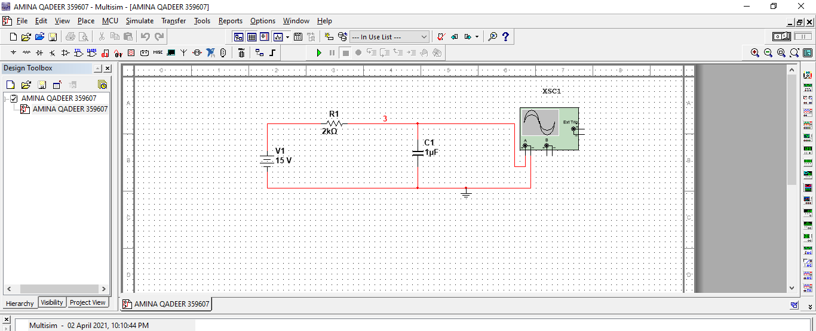

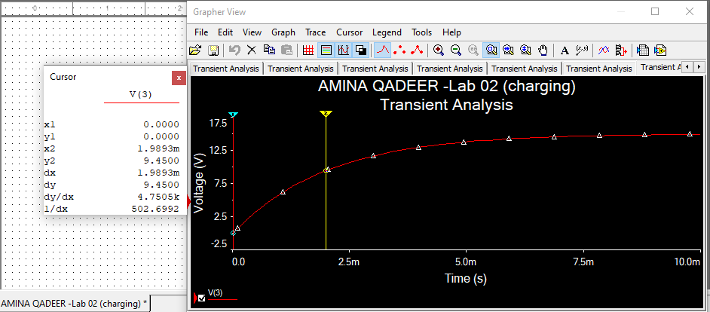

Compute the theoretical value of time constant using expression Ʈ=RC

Time Constant (theoretical) =

* Time constant (measured) = 1.98 seconds
* Coordinates are: (1.98, 9.45)
* % difference of measured and theoretical value:
* Percentage difference between measures and theoretical: 1 %

**CAPACITOR DISCHARGING**

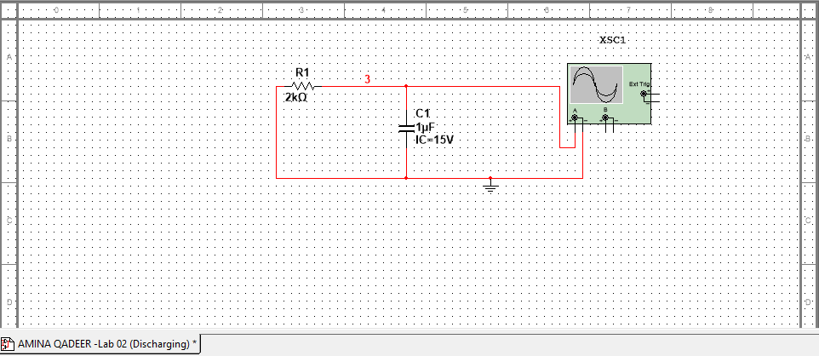

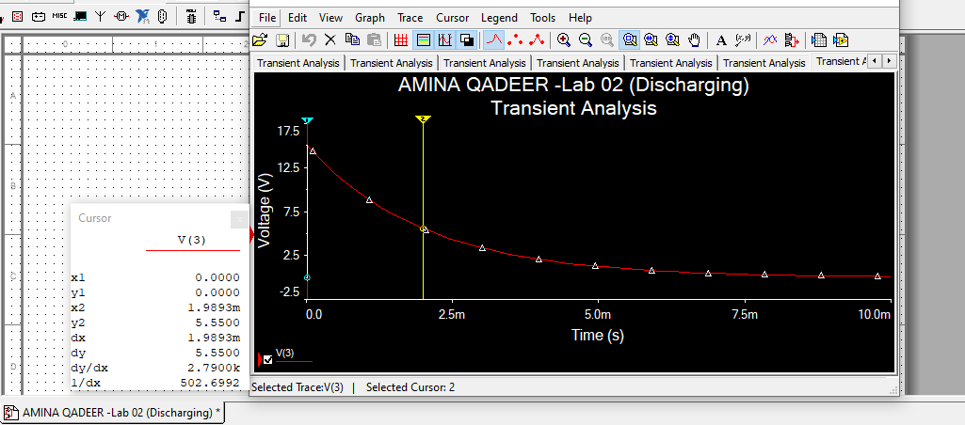

* Time constant (theoretical): 2 milliseconds
* Time constant (measured): 1.98 seconds
* Voltage at 37 % of 15 : 0.37x 15= 5.55 v
* Coordinates : (1.98, 5.55)
* Percentage difference between measures and theoretical: 1 %

**Part 2**

1. Replace DC source by a source capable of generating square waves. Use function generator for this purpose.

The output of a square wave generator alternates between two different voltages separated by a potential difference V. When the output is at higher potential the capacitor is charging up. When the output switches to lower potential, the capacitor discharges. The capacitor then alternates between charging and discharging cycles in accordance with output of a square wave generator.

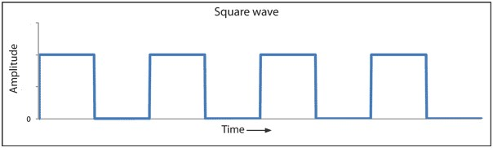

**Charging by ac source:**

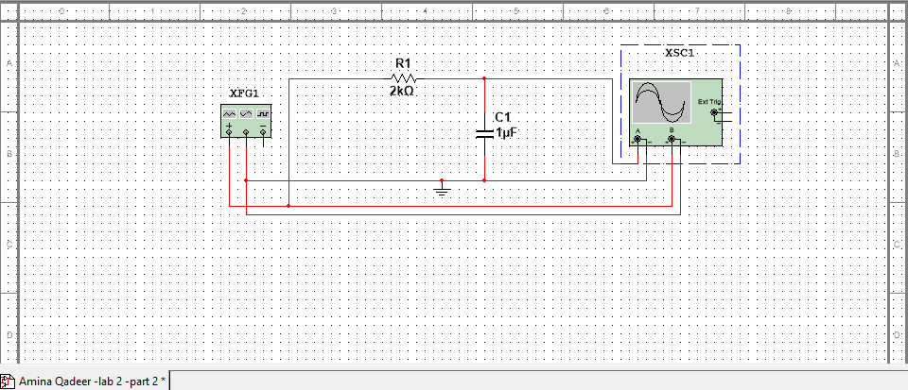

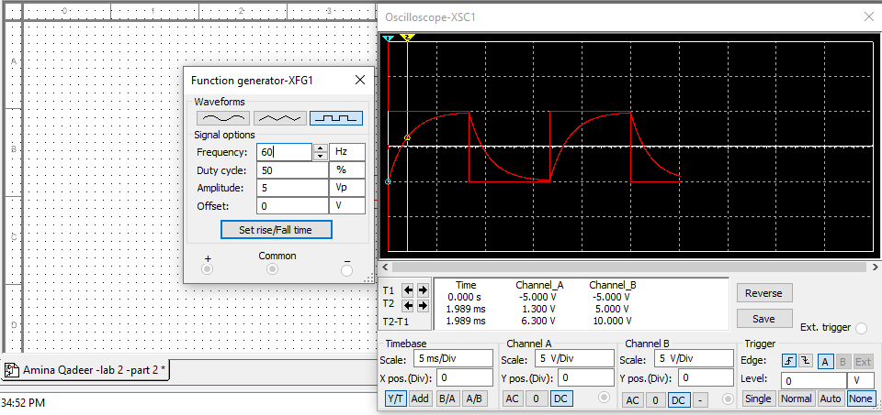

1. Connect the circuit as shown in figure below.

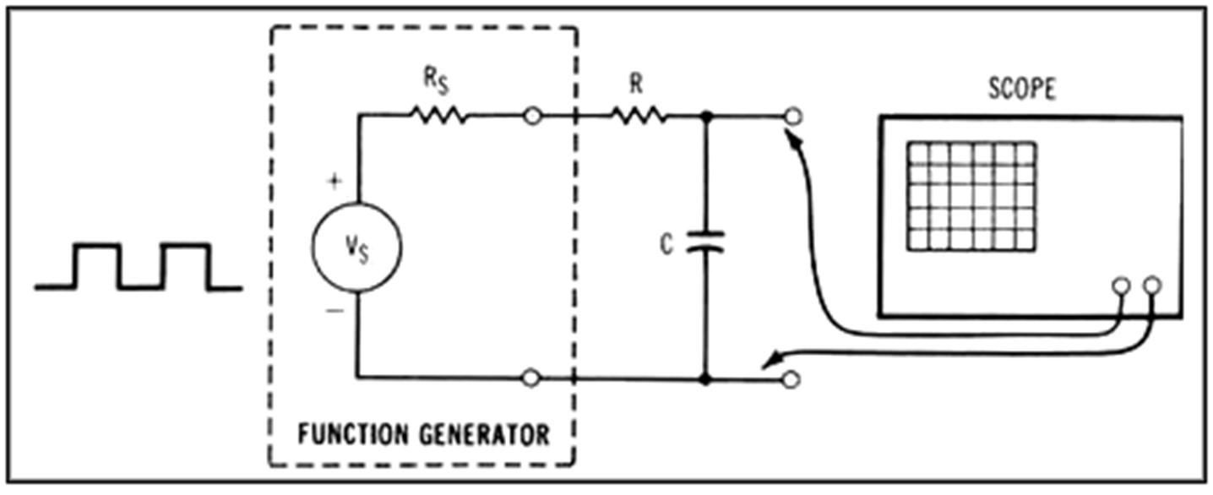

1. Adjust the frequency to such a value such that the capacitor is sufficiently charged and discharged alternatively. This can simply be done by reducing the frequency using frequency setting knob of function generator.

4

. Set peak voltage of input square wave to _5____V. Draw thi

s input wave form.

5

. Observe the output on oscilloscope and sketch the resulting graph.

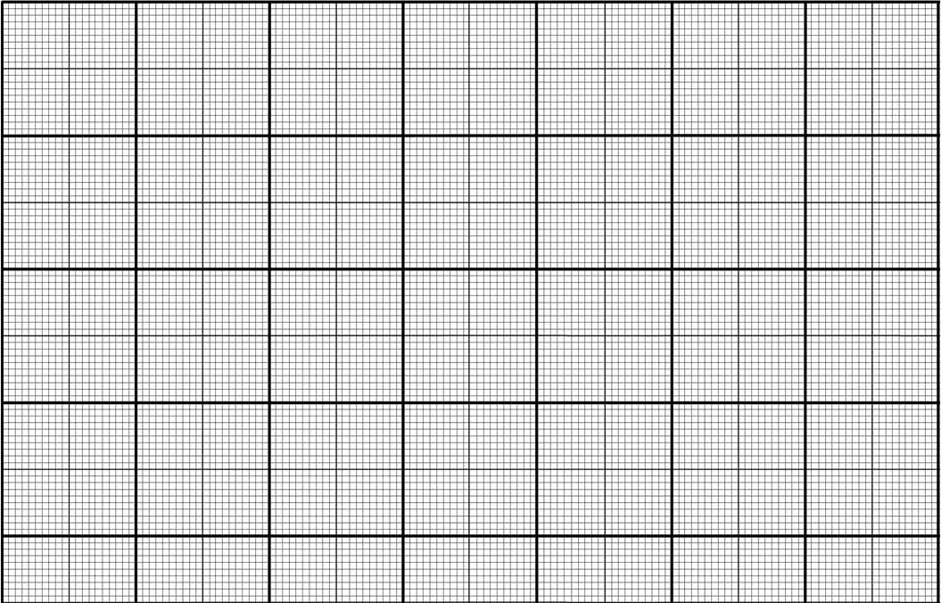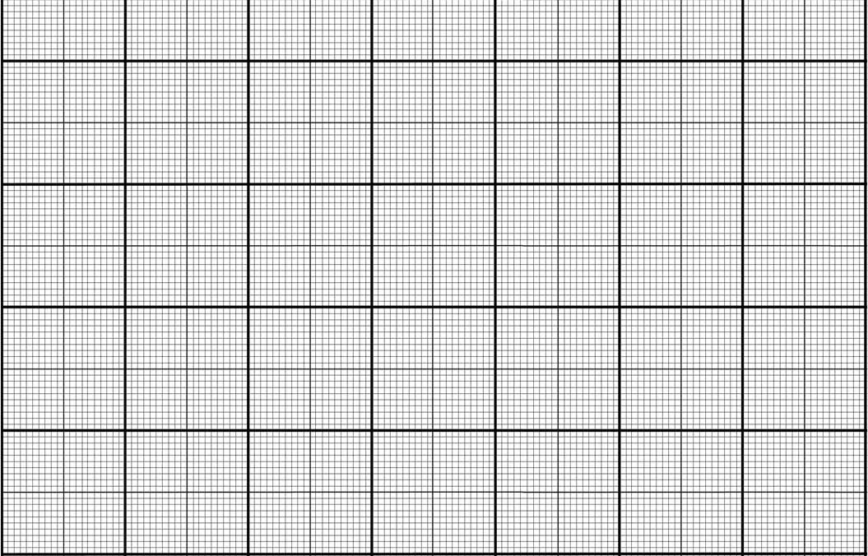

1. Using expression below calculate value of voltage across capacitor for t= 1Ƭ



=

Here t= RC

=

= 6.32

7. For the above calculated voltage across capacitor determine time from graph of output (charging portion).

Time Constant = _____1.989ms___________________________

* Percentage difference between measures and theoretical: 0.55

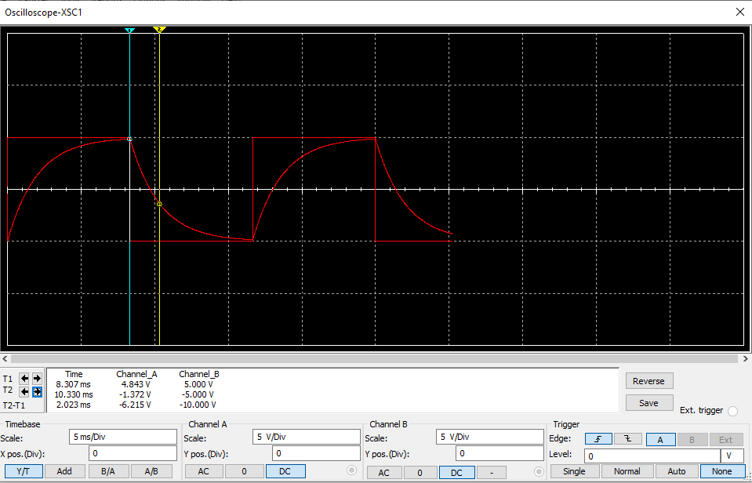

Use following expression to calculate voltage across capacitor



=3.68V

1. For the above calculated voltage across capacitor determine time from graph of output (discharging portion).

Time Constant = __2.023

1. Compare theoretical value of Time Constant

* Percentage difference between measures and theoretical: 0.5